RUTH POLIAKONI

xxxxxxx**xxxxxxxxx**

ruthpoliakon rupol [ruthpoli.com](http://ruthpoli.com/)

SKILLS



JavaScript HTML CSS Python



LESS/SASS React Redux WordPress



PHP SQL PostgreSQL NodeJS



Express Authentication REST Git

PROFESSIONAL EXPERIENCE



Web Developer Waxcreative Design

Remote Sept 2019 - Present

Consistently build and maintain responsive, standards-compliant, cross-browser, accessible websites using HTML, CSS, and JavaScript to increase client web presence and drive sales

Implement WordPress templates, plugins, child themes, custom post types, elds, and taxonomies, maximizing codebase resuability and client ease of update

Collaborate with project managers, designers, and other developers to bring client vision to life

Spearheaded a cross-functional team including a project manager and UX designer to successfully deliver a rebuild of our company site, including emphasis on accessibility and modern web standards



Responsive Web Design Accessibility



Automated Testing Data Analysis



Analytics Agile Work ow Angular

EDUCATION AND TRAINING

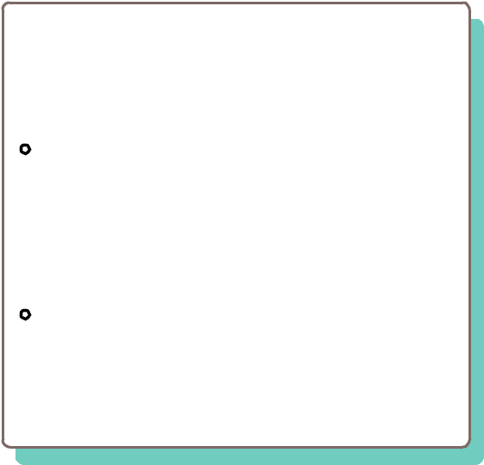

Lambda School

Full Stack Web Development and Computer Science

|  |  |
| --- | --- |
| Remote | Oct 2020 |

Engaged in an 18 month Computer Science & Software Engineering Academy that provides an immersive curriculum with a focus on computer science, software engineering, and web development

Gained hands-on experience with cross-functional Agile teams to ship production-ready code using React, Redux, NodeJS, Express, and PostgreSQL



Colorado State University

BS Fish, Wildlife, and Conservation

Biology

May 2013

Honors: Magna Cum Laude, Lilla B.

Morgan Scholarship, Dean's List, Philip A.

Connolly Memorial Scholarship

Teacher Denver Academy

Denver, CO Aug 2017 - Jan 2019

Created a completely paperless learning environment by utilizing G Suite and maintaining a classroom website, reducing waste by 90% and increasing accessibility and communication

Trained a team of ve fellow teachers on new virtual learning environments and other assistive technologies

Devised eUective and purposeful lesson plans while di erentiating lessons to accommodate diverse learners

Communicated e ectively with parents and updated student les and anecdotal records

PROJECTS



|  |  |  |  |  |  |  |
| --- | --- | --- | --- | --- | --- | --- |
| Full Stack Developer | |  |  |  |  | [CarPal](https://www.letscarpal.com/) |
| React | Redux | NodeJS | Express | MapBox | Twilio | |

*A socially-focused, environmentally aware carpooling/ridesharing app.*

Collaborated on a remote distributed team of 7 Software Engineers and 1 Data Scientist

Performed user research using surveys and interviews to determine features, creating wireframes and user Vows Implemented db architecture, authentication, MapBox integration, form validation, and ride user ow, with test driven development and maintanability as focus points



Full Stack Developer [Key Conservation](https://key-conservation.netlify.com/)

React Redux NodeJS Express

*A conservation fundraising and networking app.*

Conceptualized and developed a fully responsive application in 2 weeks to successfully deliver the product on time while maintaining high code quality

Engineered product architecture with maintainability and reusability in mind, utilizing React Redux on the front end and NodeJS and Postgres on the backend